Confidential to the ApiNZ Board and AFB Management Agency

American Foulbrood National Pest Management Plan

Governance Report
Apiculture New Zealand (Inc)

Report 31 – February 2023

Report Compiled By
Clifton King
AFB NPMP Compliance Manager

Highlights Report

- Plan Order Consultation

The following work has been completed in preparation to submit the proposal to the Minister:
- Analysis of round three submissions
- Response to Round three submissions
- Round three consultation summary booklet
- Proposal to amend and extend the Biosecurity (National American Foulbrood Pest Management Plan) Order 1998
- Consultation summary report (for all three rounds of consultation)
These documents have been submitted to the Board for their consideration on 14 February 2023.

- Development of Online AFB Training

The online recognition training course went live on 21 November, and the online refresher course went live on 5 December. The new classroom-based refresher will be used from February 2023 onwards.
44 participants had completed the online training course and a further 95 students completed the online refresher course by the end of January 2023. Participant feedback on both courses has been positive.

- Certificates of Inspection
2,640 beekeepers completed a COI prior to 15 December 2022. A further 160 beekeepers have completed a late COI up until 7 February 2023.

All beekeepers that had defaulted on their COI obligations were sent a default notice on 16 December 2022, and a follow-up default notice 19 January 2023 advised beekeepers that the Management Agency would inspect their colonies on default should they fail to complete a late COI by 17 February 2023.

As of 7 February 2023, 975 beekeepers are in default of their COI obligations. They own 9,841 colonies on 1,734 apiaries.
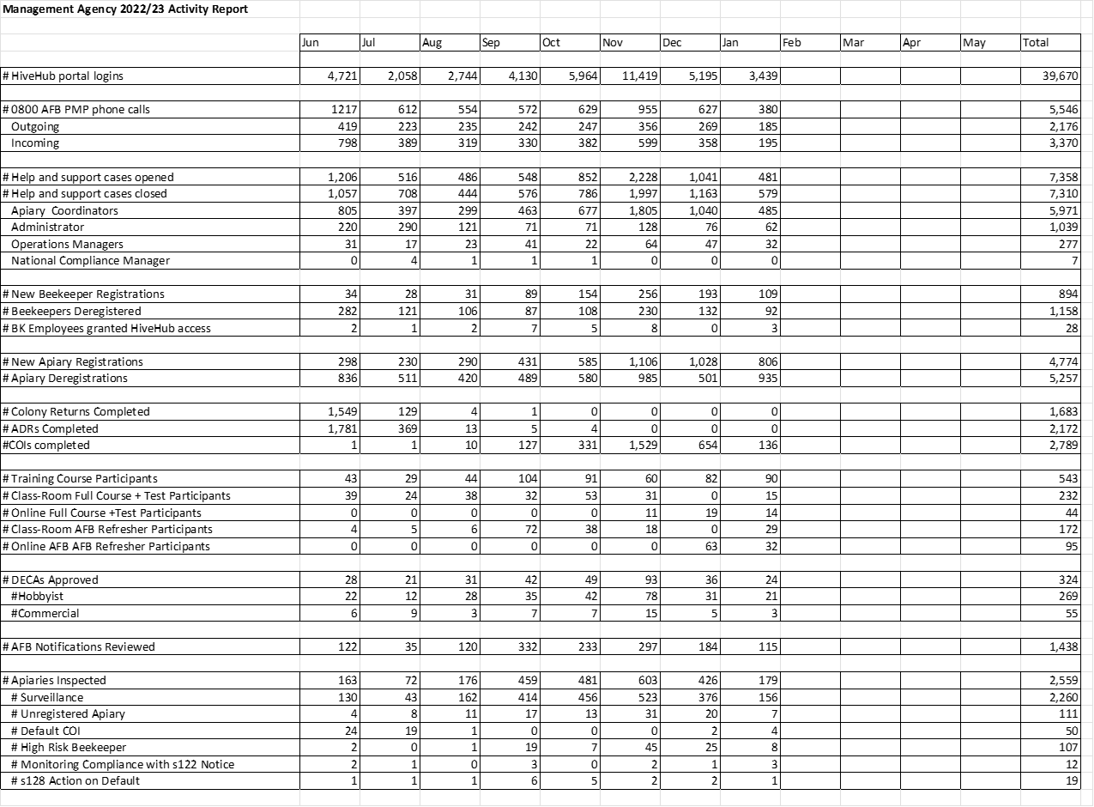
Statistics as of 7 February 2023
Registered beekeepers | 10,103
Registered apiaries | 60,622
Colonies on registered apiaries | 720,576
2022 ADRs submitted | 9,092
2022 ADRs submitted by 1 June | 6,922 (71.7%)
2022 COI submitted | 2,800
2021 COI submitted by 15 December | 2,640
# Registered Beekeepers with DECA | 5,329 (52.8%)

Note: The beekeeping industry and particularly the commercial sector is continuing to contract. From February 2022 until February:
- The number of registered beekeepers declined from 10,465 to 10,103
- The number of registered apiaries declined from 63,761 to 60,622, and
- The number of colonies on registered apiaries decreased from 843,069 to 720,576.

Clifton King
AFB NPMP Compliance Manager

